

**SANYO SA-KC12BG3**

**Rs. 292,000/-**

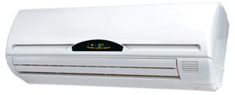

**Product Features**

* anti dust
* 24 hours timer
* Independent Dehumidification
* Low Noise Air Flow System
* Easy Clean Panel

**Specification**

**Type** Wall Mounted Split AC

**Cooling (Btu/h)** 41000

**Voltage (V)** 220-240

**Power Input (W)** 3500

**EER (Btu/W-h-W/W)** 6.4-3.4